**Package & Freight Receiving Management Application**

User Manual

Table of Contents

|  |  |
| --- | --- |
| Introduction | 1 |
| Getting Started | 2 |
|  |  |
|  |  |
|  |  |
|  |  |
|  |  |
|  |  |

Introduction

This application is specifically designed to allow Ozarks Technical Community College’s Shipping and Receiving Management Office to accurately and efficiently receive, track, and distribute freight throughout the college and its campuses. Using a remote database this application stores packages and their status as well as other common and important information. Creating reports, delivery sheets, and list print out are made easily through the various menus and interfaces offered by the application.

Getting Started

Installing the application:

Insert the disc provided into the computers disk drive.

When prompted click install and run. This make take a couple minutes.

Once installed, double click on the icon on the desktop to start the application.

When the application starts you will be prompted to log in.

For first time setup use the Username: Admin and the Password: Admin.

Logging in for the First Time

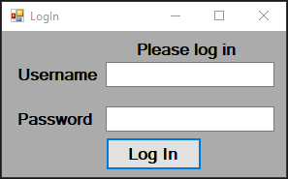Once the application starts, you will be prompted to login. For first-time setup use the **USERNAME: admin** and the **PASSWORD: admin**. (Once initial setup is complete, and an administrative User created this username and password will no longer allow you to login).

Fig 1.1

After successfully logging in, the Main Menu will load. You will be presented with four buttons Receiving, History, Manage, and Settings. To complete initial setup, click Settings.

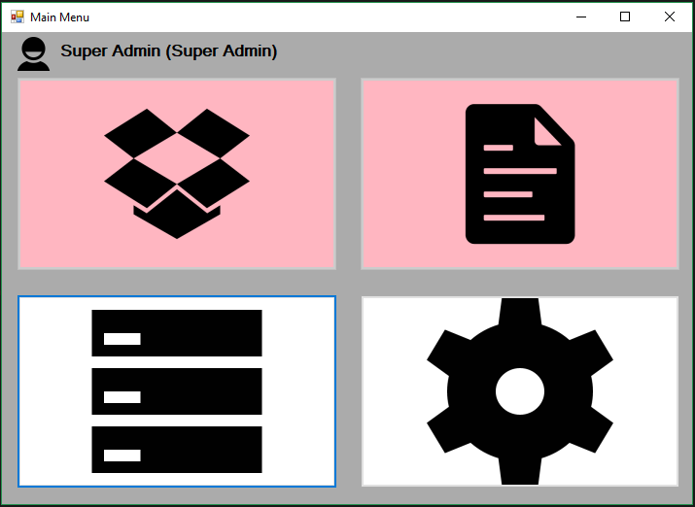

Fig 1.2

Manage

Settings

In the Settings menu, you will need to enter the database connection information. To get this information contact your database administrator. Once you have entered the connection information, test the connection by pressing the test connection button. If the connection is successful, a pop-up with “Connection Successful” will display. If the connection fails, contact the database administrator. After the connection success message displays, use the “Save Connection” button to save the connection information. When you click the “Save Connection” button the application will restart so that the connection can be active through-out the application.

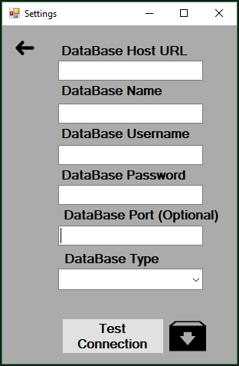

Fig 1.3

Save Connections

After the application restarts, you will need to add a User with administrative privileges. To start this process login with the **Username: admin** and the **Password: admin**. In the Main Menu, click Manage (See figure 1.2). Once in the Manage menu click the User button to select the User Data Table.

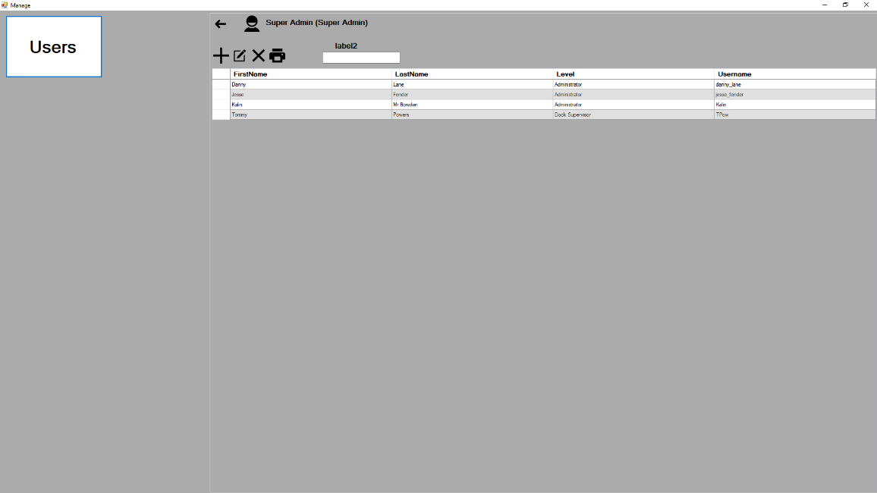

Fig 1.4

User Button

User Button

Back to Main Menu

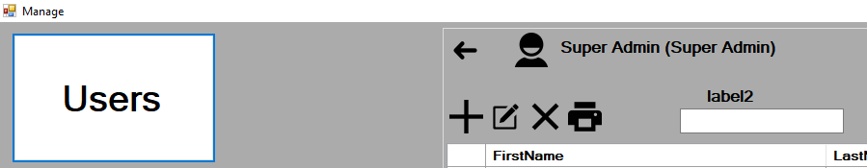

Fig 1.5

Add

After selecting the User button click Add to add a user (see fig. 1.5). The window to add a User will display (see fig. 1.6).

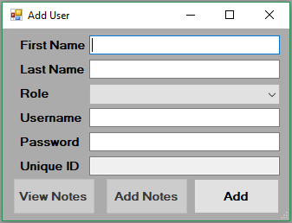

Fig 1.6

Fill each field with the requested information. Its important, that when adding a User for the first time, the “Administrator” role be selected so that the user will be able to access all functions. Once all fields have been filled, click the Add Button to create the User.

Click the Back button to return to the Main Menu (see fig. 1.5). In the Main Menu, click the User icon (see fig. 1.2) to bring up the Login form (see fig. 1.1). Log in as the User you created to complete the First Time Setup.

**Receiving**

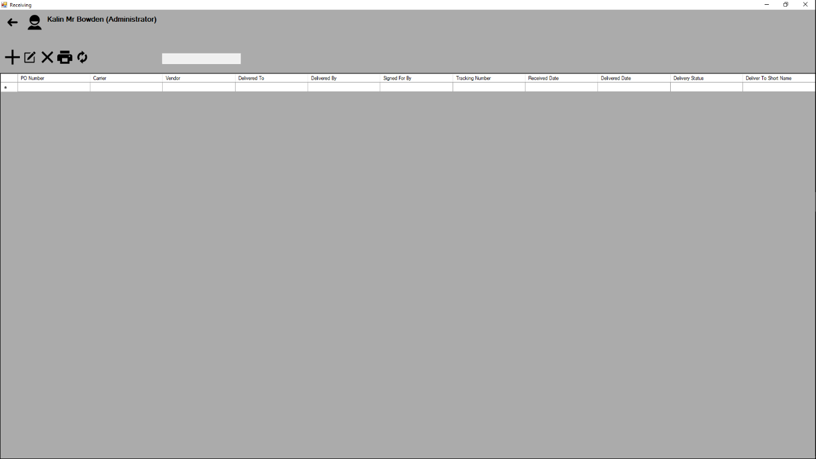**Getting to Know the Receiving Form**

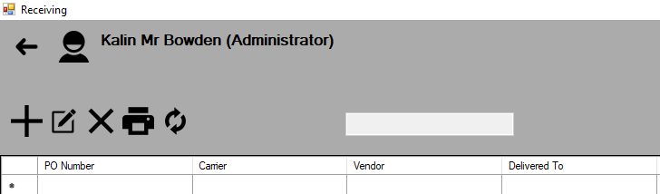

Search

Refresh

Edit

Back

Print

Delete

Add



Select All

Data Columns

Cells

Data Rows

**How to Receive a Package**

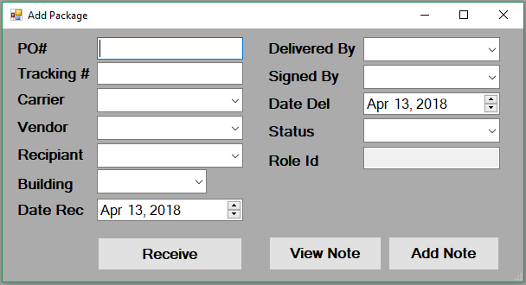To add a package to the daily receiving list, click the Add button (see fig 2.2) to display the Add Package Form.

Fill all the required fields with the necessary data. At a minimum a Package needs a Tracking Number, Carrier, Vendor, Recipient, Building, and a Date Received. Click Receive to receive the Packages (see fig. 2.2).

**Editing an Existing Packages**

To edit an existing Package, Click the row to highlight the selected package (see fig. 2.3). In the menu click the Edit button (see fig. 2.2) to display the Edit Package Form.

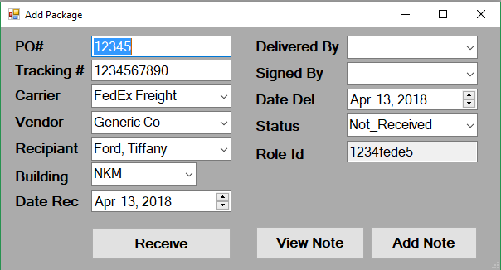

To

Deleting packages

Printing the Log